15.467 Assignment 1

Songhao Li

1(a). By running Portfolio Optimizer with the constraints that set cash holdings to be zero and the objective to maximize the Sharpe Ratio, the OCRA portfolio weights are as below:

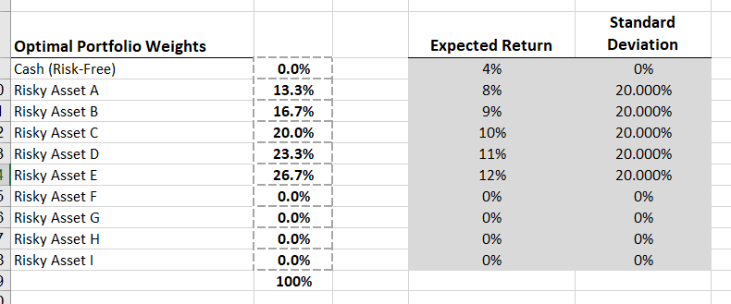

1(b) He is wrong. Running the Portfolio Optimizer with the constraint that the target expected return = 12% and the objective to minimize standard deviation, we have a portfolio as below that has a lower standard deviation (15.49%) compared with asset E

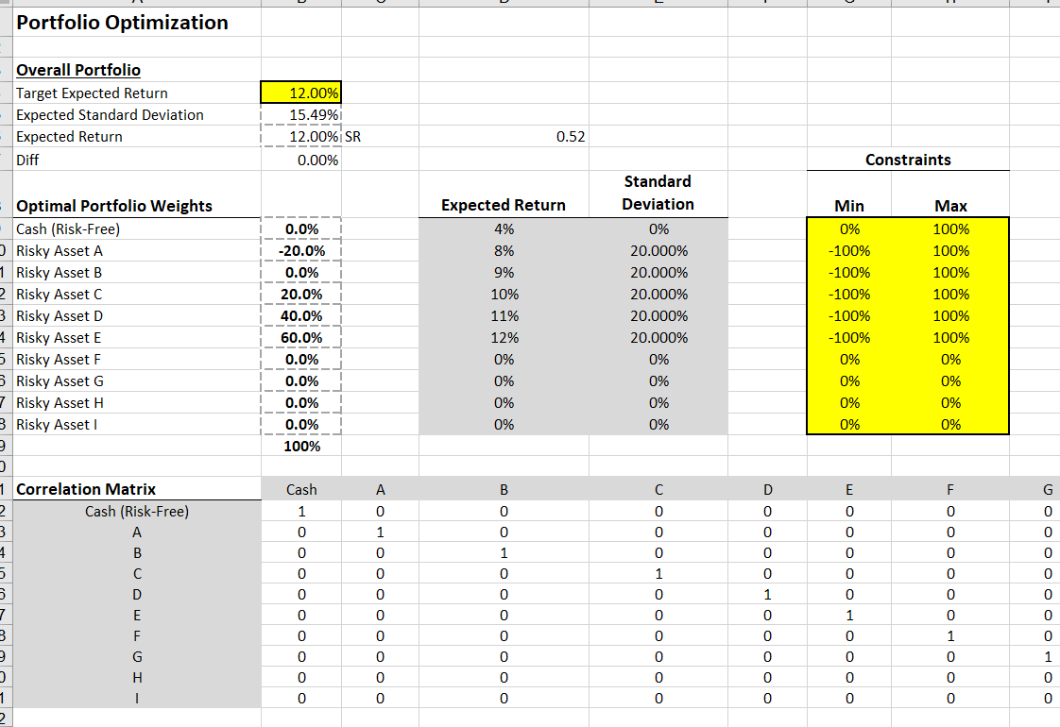

1(c) By Running the same optimization program as 1(a) and change the inputs, the revised weights are as below:

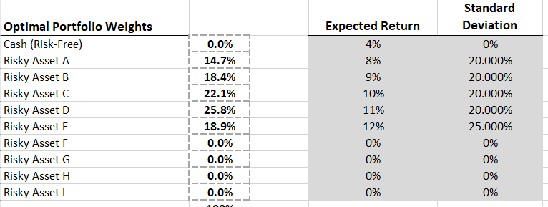

Compared with the weights before, now we have decreased weight for risky asset E, because now E has higher standard deviation and risk.

2(a) The expected return of Stock A is alpha + risk free rate = 10%. Running the portfolio optimizer: 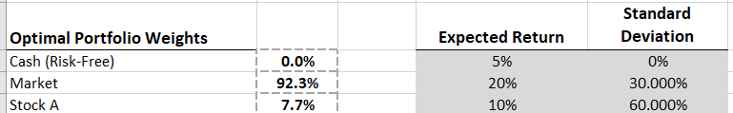

The intuition to hold stock A is that:

1. It has alpha, which means holding A can offer extra return beyond CAPM.
2. It is uncorrelated with the market so that holding A with the market portfolio offers additional diversification.

2(b) By CAPM: $β=\frac{σ_{i}M}{σ_{M}^{2}} ⇒ corr_iM =\frac{σ_{i}M}{σ_{M}*σ_{i}} = -0.5$

Running the portfolio optimizer:

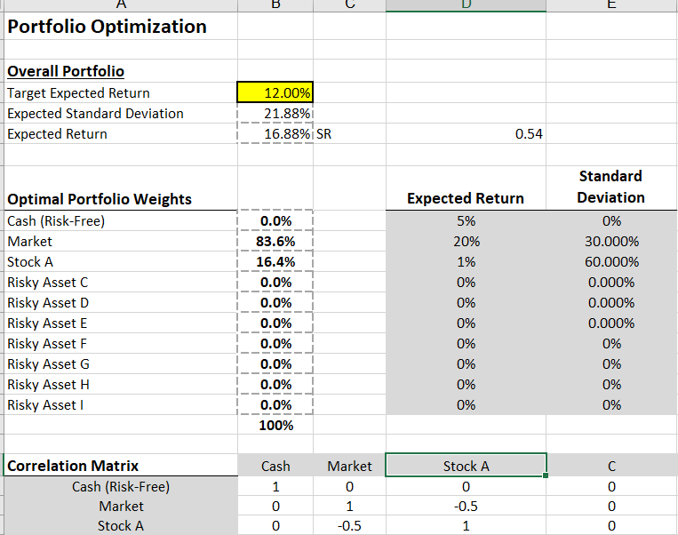

Now the intuition to hold Stock A is:

1. It has alpha which means holding A can offer extra return beyond CAPM.
2. It is negatively correlated with the market so that holding A with the market portfolio offers insurance.